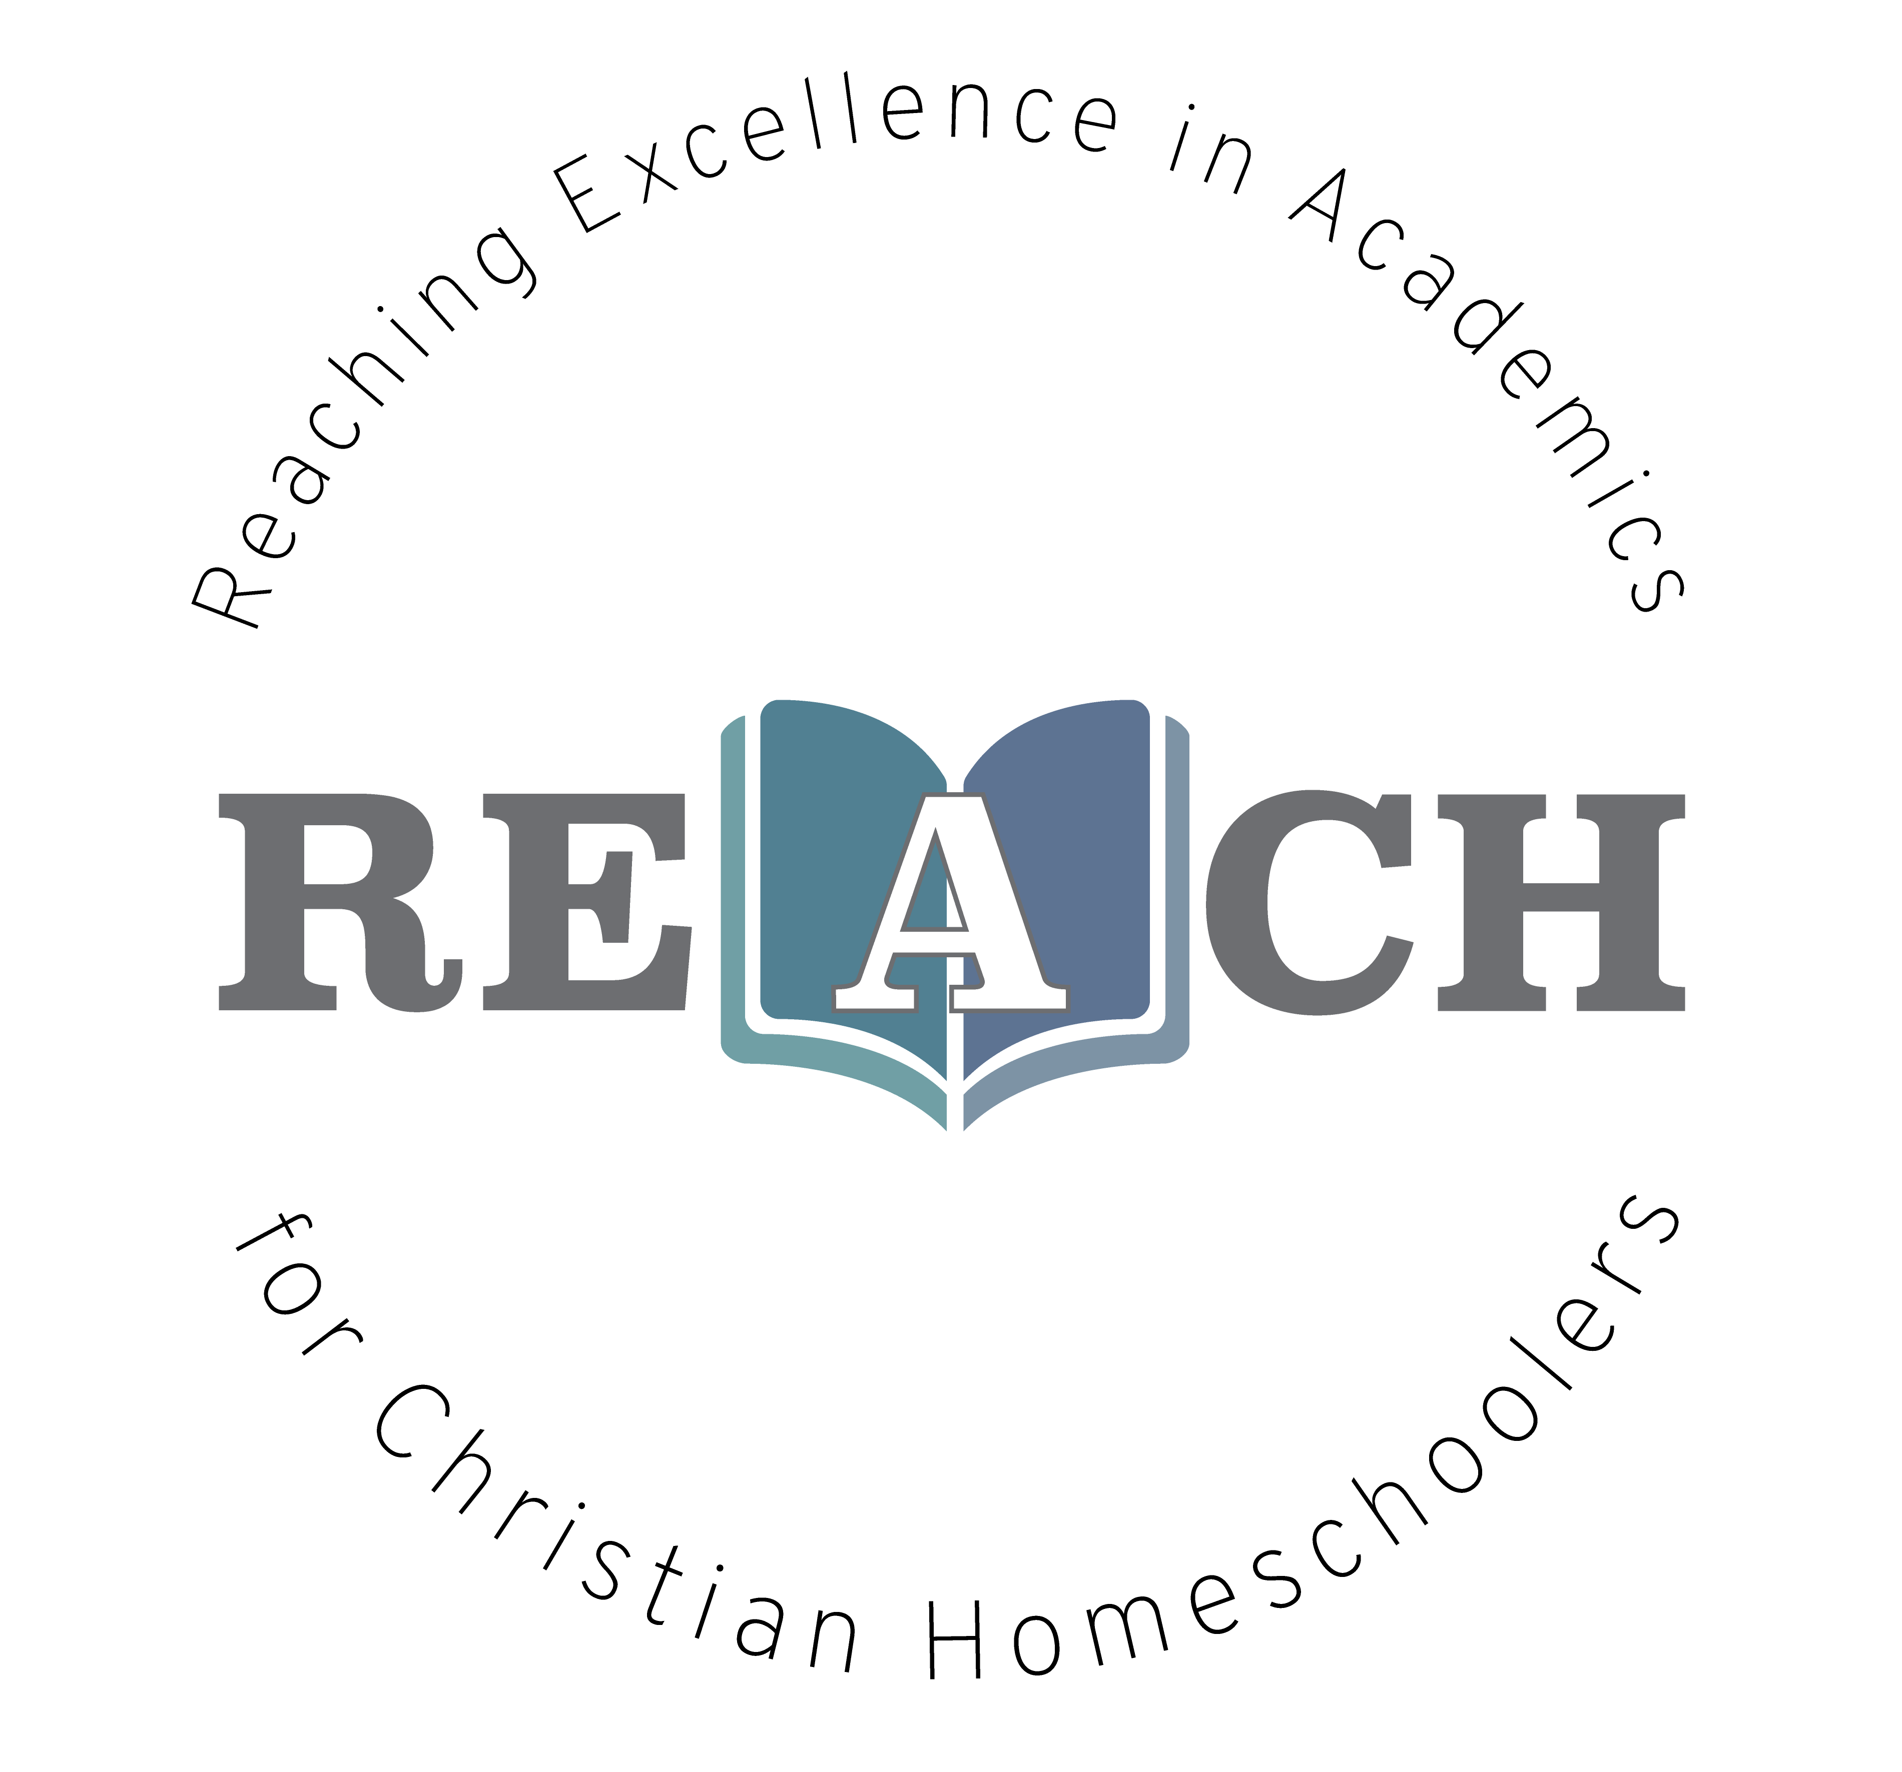
What is Chemistry? What is everything in our universe made of? We will answer this question and so many more through a Christian perspective as we discover the elements of the periodic table and how they combine to make up the world around us. We will complete several experiments with items that are readily available in your own home! Come along with us as we journey into the world of atoms, molecules, chemical bonds and formulas, and the building blocks for all matter. This pre-chemistry course gives students an excellent overview to give them a solid foundation for their high school career.

Christian Kids Explore Chemistry
Mrs. Christine Filipek~
I live on a small farm in southeast Michigan with my wonderful family. My husband, who is a music teacher, and I have been homeschooling our four children for over 20 years. Autumn is our oldest, she graduated from Pensacola Christian College studying education and art. Our son, Wesley is a senior studying criminal justice and Ellie is a sophomore studying nursing at Pensacola Christian College. Molly is a senior at home studying veterinarian medicine. We LOVE animals, we have 2 horses, a goat, tons of chickens, 3 turkeys (named Thanksgiving, Christmas, and Easter), a bunny, several cats, a parrot, lovebird and 2 dogs, Pete and Tucker. We have had the opportunity to raise many domestic and wild animals. I love gardening, reading, sewing, watching movies (going to the drive-in) and hanging out with my family! Besides teaching my own children over the years, I also helped several families in my home by sharing my love for science. I love the hands-on aspect of science. I love the hands on aspect, it helped us understand so much more of what we were learning and it was so much FUN! I own and operate REACH Tutorial, teaching a variety of science classes and Latin to all ages. Both my husband and I are very active in our local and state homeschool groups. We have served on the boards of two local homeschool groups for over 15 years and look forward to helping other homeschool families.

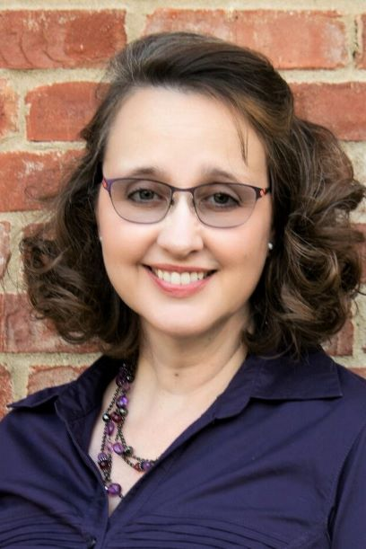
REACH Tutorial

Class Information

Class Name: Self Paced Christian Kids Explore Chemistry

Teacher Information

Teacher: Christine Filipek
Email: mrscfilipek@gmail.com

Required Course Materials

Christian Kids Explore Chemistry by Robert Ridlon Jr. and Elizabeth Ridlon. Published through Bright Ideas Press. Students will also need various household supplies listed on pages 3, 52, 96-97, 158-159, and 204-205.

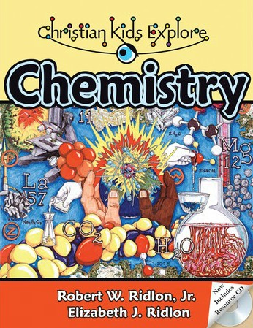

Student Success
Whatever you do, work heartily, as for the Lord and not for men (Col 3:23 ESV)
So, whether you eat or drink, or whatever you do, do all to the glory of God. (1Cor 10:31 ESV)

Let the thief no longer steal, but rather let him labor, doing honest work with his own hands, so that he may have something to share with anyone in need. (Eph 4:28 ESV)
The plans of the diligent lead surely to abundance, but everyone who is hasty comes only to poverty. (Prov 21:5 ESV)
Pray for us, for we are sure that we have a clear conscience, desiring to act honorably in all things. (Heb 13:18 ESV)
Whoever pursues righteousness and kindness will find life, righteousness, and honor. (Prov 21:21 ESV)
Whoever walks in integrity walks securely, but he who makes his ways crooked will be found out. (Prov 10:9 ESV)

Grading Policy
Course Grading Scale (in percent):
A 96-100
A- 90-95
B+ 87-89
B 83-86
B- 80-82
C+ 77-79
C 73-76
C- 70-72
D+ 67-69
D 63-66
D- 60-62
F 0-59

Categories
Weekly assignments 50% of final grade
Assessments/quizzes 50% of final grade
100% total

Philippians 4:8
Finally, brethren, whatever is true, whatever is honorable, whatever is right, whatever is pure, whatever is lovely, whatever is of good repute, if there is any excellence and if anything worthy of praise, dwell on these things.

CKE Self-Paced Chemistry Schedule with Mrs. Filipek

 |  | Chapters | Lessons | Assessments
1 |  | 1-2 | Introduction to Chemistry and the tools that we use. | Chapter 1-2 reading
2 |  | 3-4 | Matter, elements, and the periodic table. | Chapter 3-4 reading
3 |  | 5-6 | Mixtures, compounds and atoms | Review over chapters 1-5
4 |  | 7-8 | Atoms, atomic numbers and atomic mass | Chapter 6-8 reading
5 |  | 9-10 | Periodic table and molecules | Review over chapters 6-10
6 |  | 11-12 | Chemical bonds | Chapter 11-12 reading
7 |  | 13-14 | Formulas and Compounds | Chapter 13-14 reading
8 |  | 15-16 | Reactions and acids | Chapter 15-16 reading
9 |  | 17-18 | Bases and Salts | Review over chapters 11-18
10 |  | 19-20 | Solids, liquids and gases | Chapter 19-20
11 |  | 21-22 | Gas laws and changes of state | Chapter 21-22 reading
12 |  | 23-24 | Solutions and hydrocarbons | Review over chapters 19-24
13 |  | 25-26 | Alkanes and alkenes | Chapter 25-26 reading
14 |  | 27-28 | Alkynes and alcohols | Chapter 27-28 reading
15 |  | 29-30 | Esters and biochemistry | Review over chapters 25-30

Copyright:
Copyright © 2017 by Michelle Glandon. All rights reserved. No part of this publication may be reproduced or shared by any means without prior written permission of the publisher. Send permission requests to mrs.glandon@icloud.com.

