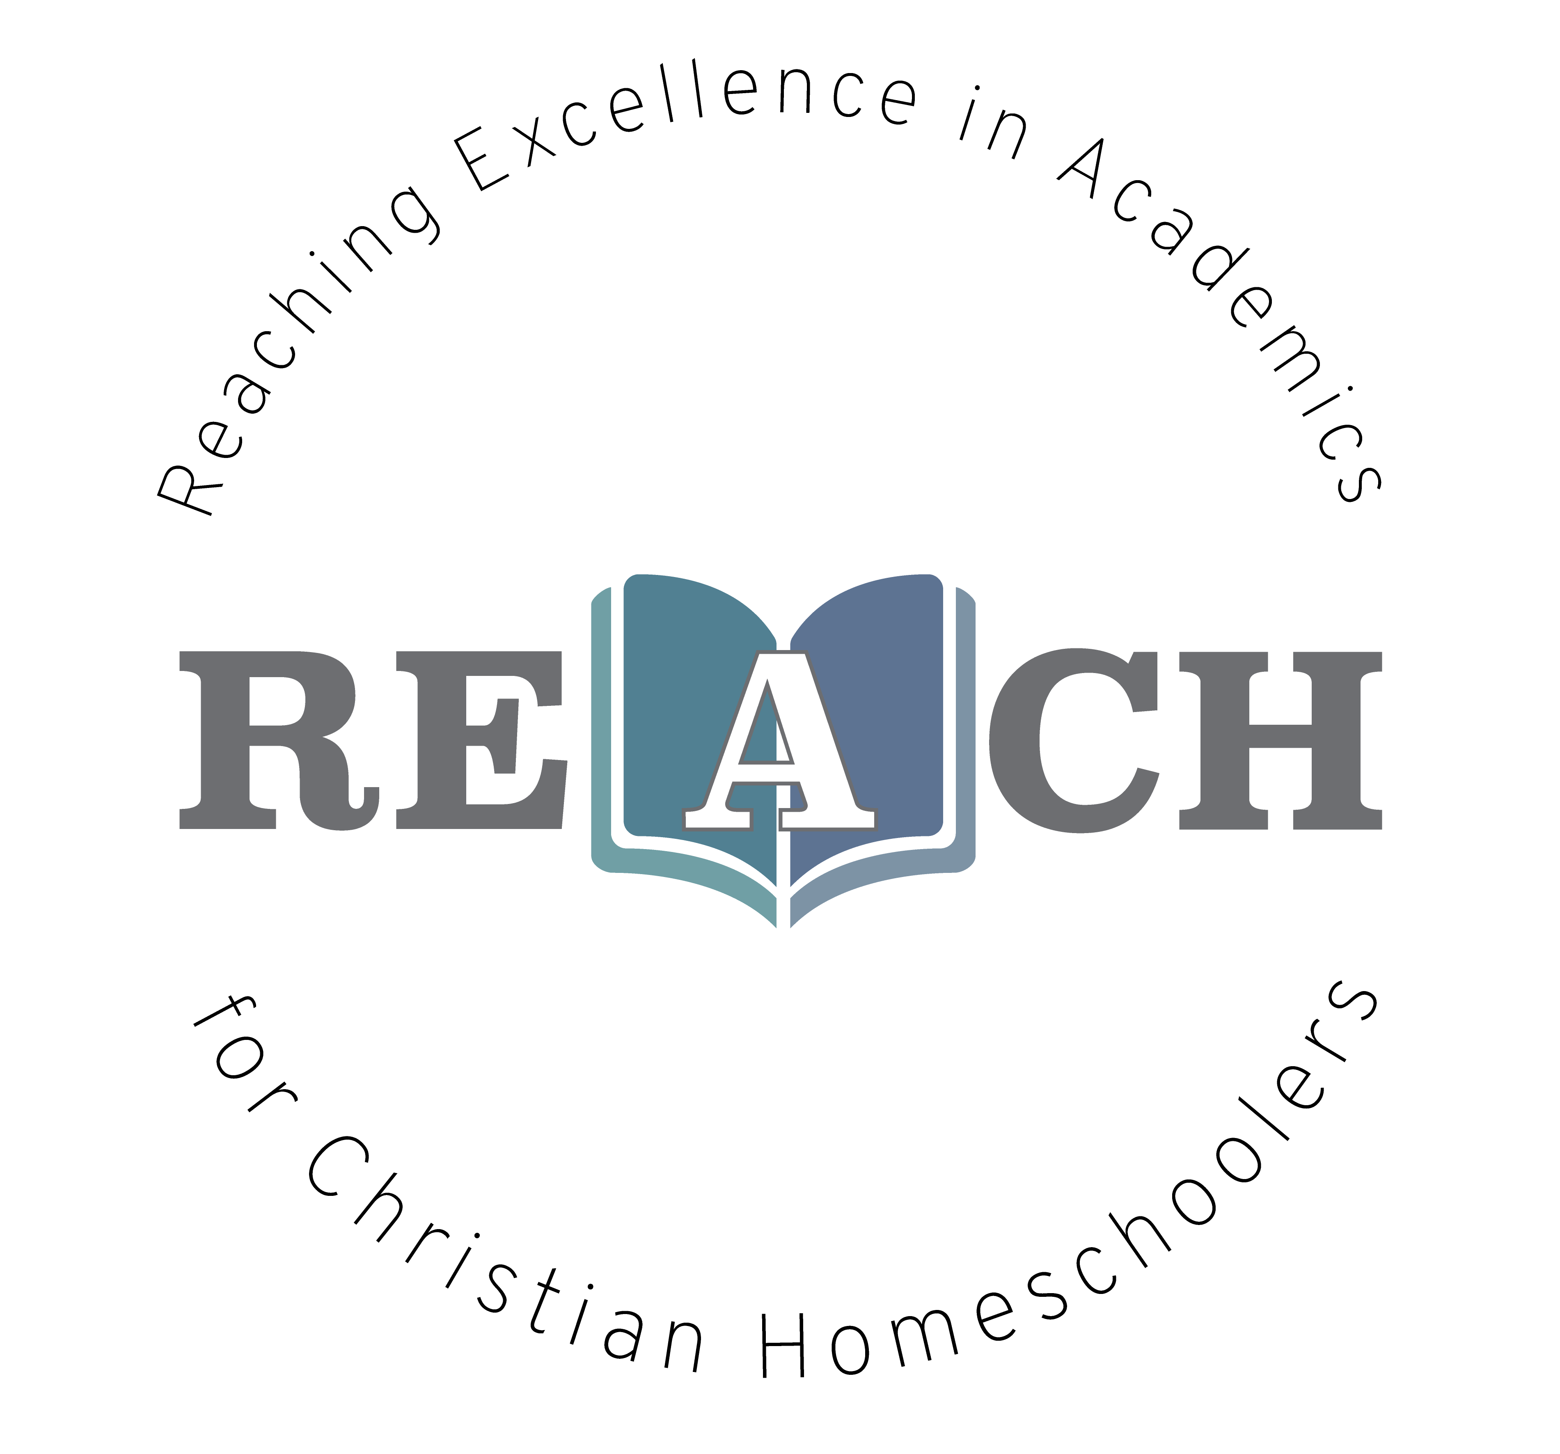

What is gravity? What is matter and why does it behave the way it does? Did you ever wonder how an x-ray works? These questions and many more will be answered as we delve into the world of Physics. Physics gives us a glimpse into the materials, laws, and structures of God’s universe. We will learn about matter and energy in great detail and see how God is a God of order, we will learn how atoms and molecules make up matter and the different states matter can take: solid, liquid, or gas. Pre-physics is a great introduction to the concepts behind more complex physics and will prepare you with a solid foundation to prepare you for high school career.

Christian Kids Explore Physics
Mrs. Christine Filipek~
I live on a small farm in southeast Michigan with my wonderful family. My husband, who is a music teacher, and I have been homeschooling our four children for over 20 years. Autumn is our oldest, she graduated from Pensacola Christian College studying education and art. Our son, Wesley is a senior studying criminal justice at Pensacola Christian College. Ellie is a sophomore studying nursing at Pensacola Christian College and Molly is a senior at home studying veterinarian medicine. We LOVE animals, we have 2 horses, a goat, tons of chickens, 3 turkeys (named Thanksgiving, Christmas, and Easter), a bunny, several cats, a parrot, lovebird and 2 dogs, Pete and Tucker. We have had the opportunity to raise many domestic and wild animals. I love gardening, reading, sewing, watching movies (going to the drive-in) and hanging out with my family! Besides teaching my own children over the years, I also helped several families in my home by sharing my love for science. I love the hands on aspect of science. I love the hands-on aspect, it helped us understand so much more of what we were learning and it was so much FUN! I own and operate REACH Tutorial, teaching a variety of science classes and Latin to all ages. Both my husband and I are very active in our local and state homeschool groups. We have served on the boards of two local homeschool groups for over 15 years and look forward to helping other homeschool families.

REACH Tutorial

Class Information

Class Name: Christian Kids Physics

Teacher Information

Teacher: Christine Filipek
Email: mrscfilipek@gmail.com

Required Course Materials

Christian Kids Explore Physics by Robert Ridlon Jr. and Elizabeth Ridlon, published through Bright Ideas Press. Various household materials will be used and can be found on pages 2, 39, 103, 154, 215, and 292.

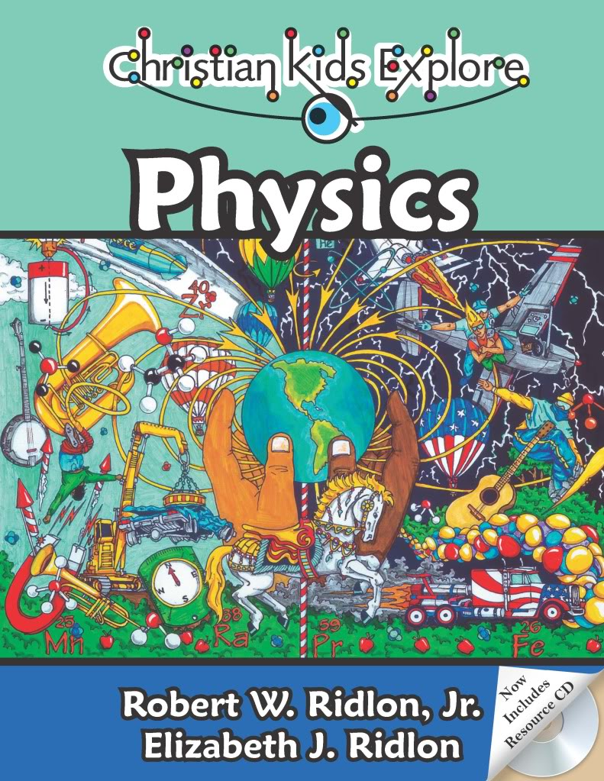

Student Success
Whatever you do, work heartily, as for the Lord and not for men (Col 3:23 ESV)
So, whether you eat or drink, or whatever you do, do all to the glory of God. (1Cor 10:31 ESV)
Let the thief no longer steal, but rather let him labor, doing honest work with his own hands, so that he may have something to share with anyone in need. (Eph 4:28 ESV)
The plans of the diligent lead surely to abundance, but everyone who is hasty comes only to poverty. (Prov 21:5 ESV)
Pray for us, for we are sure that we have a clear conscience, desiring to act honorably in all things. (Heb 13:18 ESV)
Whoever pursues righteousness and kindness will find life, righteousness, and honor. (Prov 21:21 ESV)
Whoever walks in integrity walks securely, but he who makes his ways crooked will be found out. (Prov 10:9 ESV)

Grading Policy
Course Grading Scale (in percent):
A 96-100
A- 90-95
B+ 87-89
B 83-86
B- 80-82
C+ 77-79
C 73-76
C- 70-72
D+ 67-69
D 63-66
D- 60-62
F 0-59

Categories
Weekly assignments 50% of final grade
Assessments/quizzes 50% of final grade
100% total

Philippians 4:8
Finally, brethren, whatever is true, whatever is honorable, whatever is right, whatever is pure, whatever is lovely, whatever is of good repute, if there is any excellence and if anything worthy of praise, dwell on these things.

CKE Self-Paced Physics Schedule with Mrs. Filipek
 |  | Chapters | Lesson | Assessment
1 |  | 1-2 | What is physics and how do we apply it in our world? | Chapter 1-2 reading
2 |  | 3-4 | Famous Physicists, why does it matter? | Review over chapters 1-4
3 |  | 5-6 | Atomic physics, molecules and mass | Chapter 5-6 reading
4 |  | 7-8 | Solids, liquids and gases | Chapter 7-8 reading
5 |  | 9-10 | Changes in matter and forces | Review over chapters 5-10
6 |  | 11-12 | Gravity and work | Chapter 11-12 reading
7 |  | 13-14 | Friction and energy | Review over chapters 11-14
8 |  | 15-16 | Motion | Chapter 15-16 reading
9 |  | 17-18 | Newton’s law and projectile motion | Chapter 17-18 reading
10 |  | 19-20 | Momentum and energy | Review over chapters 15-20
11 |  | 21-22 | Waves | Chapter 21-22 reading
12 |  | 23-24 | X-rays and heat | Chapter 23-24 reading
13 |  | 25-26 | Sound and music | Review over chapters 21-26
14 |  | 27-28 | Electricity and currents | Chapter 27-28 reading
15 |  | 29-30 | Magnetism and its field | Review over chapters 27-30

Copyright:
Copyright © 2017 by Michelle Glandon. All rights reserved. No part of this publication may be reproduced or shared by any means without prior written permission of the publisher. Send permission requests to mrs.glandon@icloud.com.

