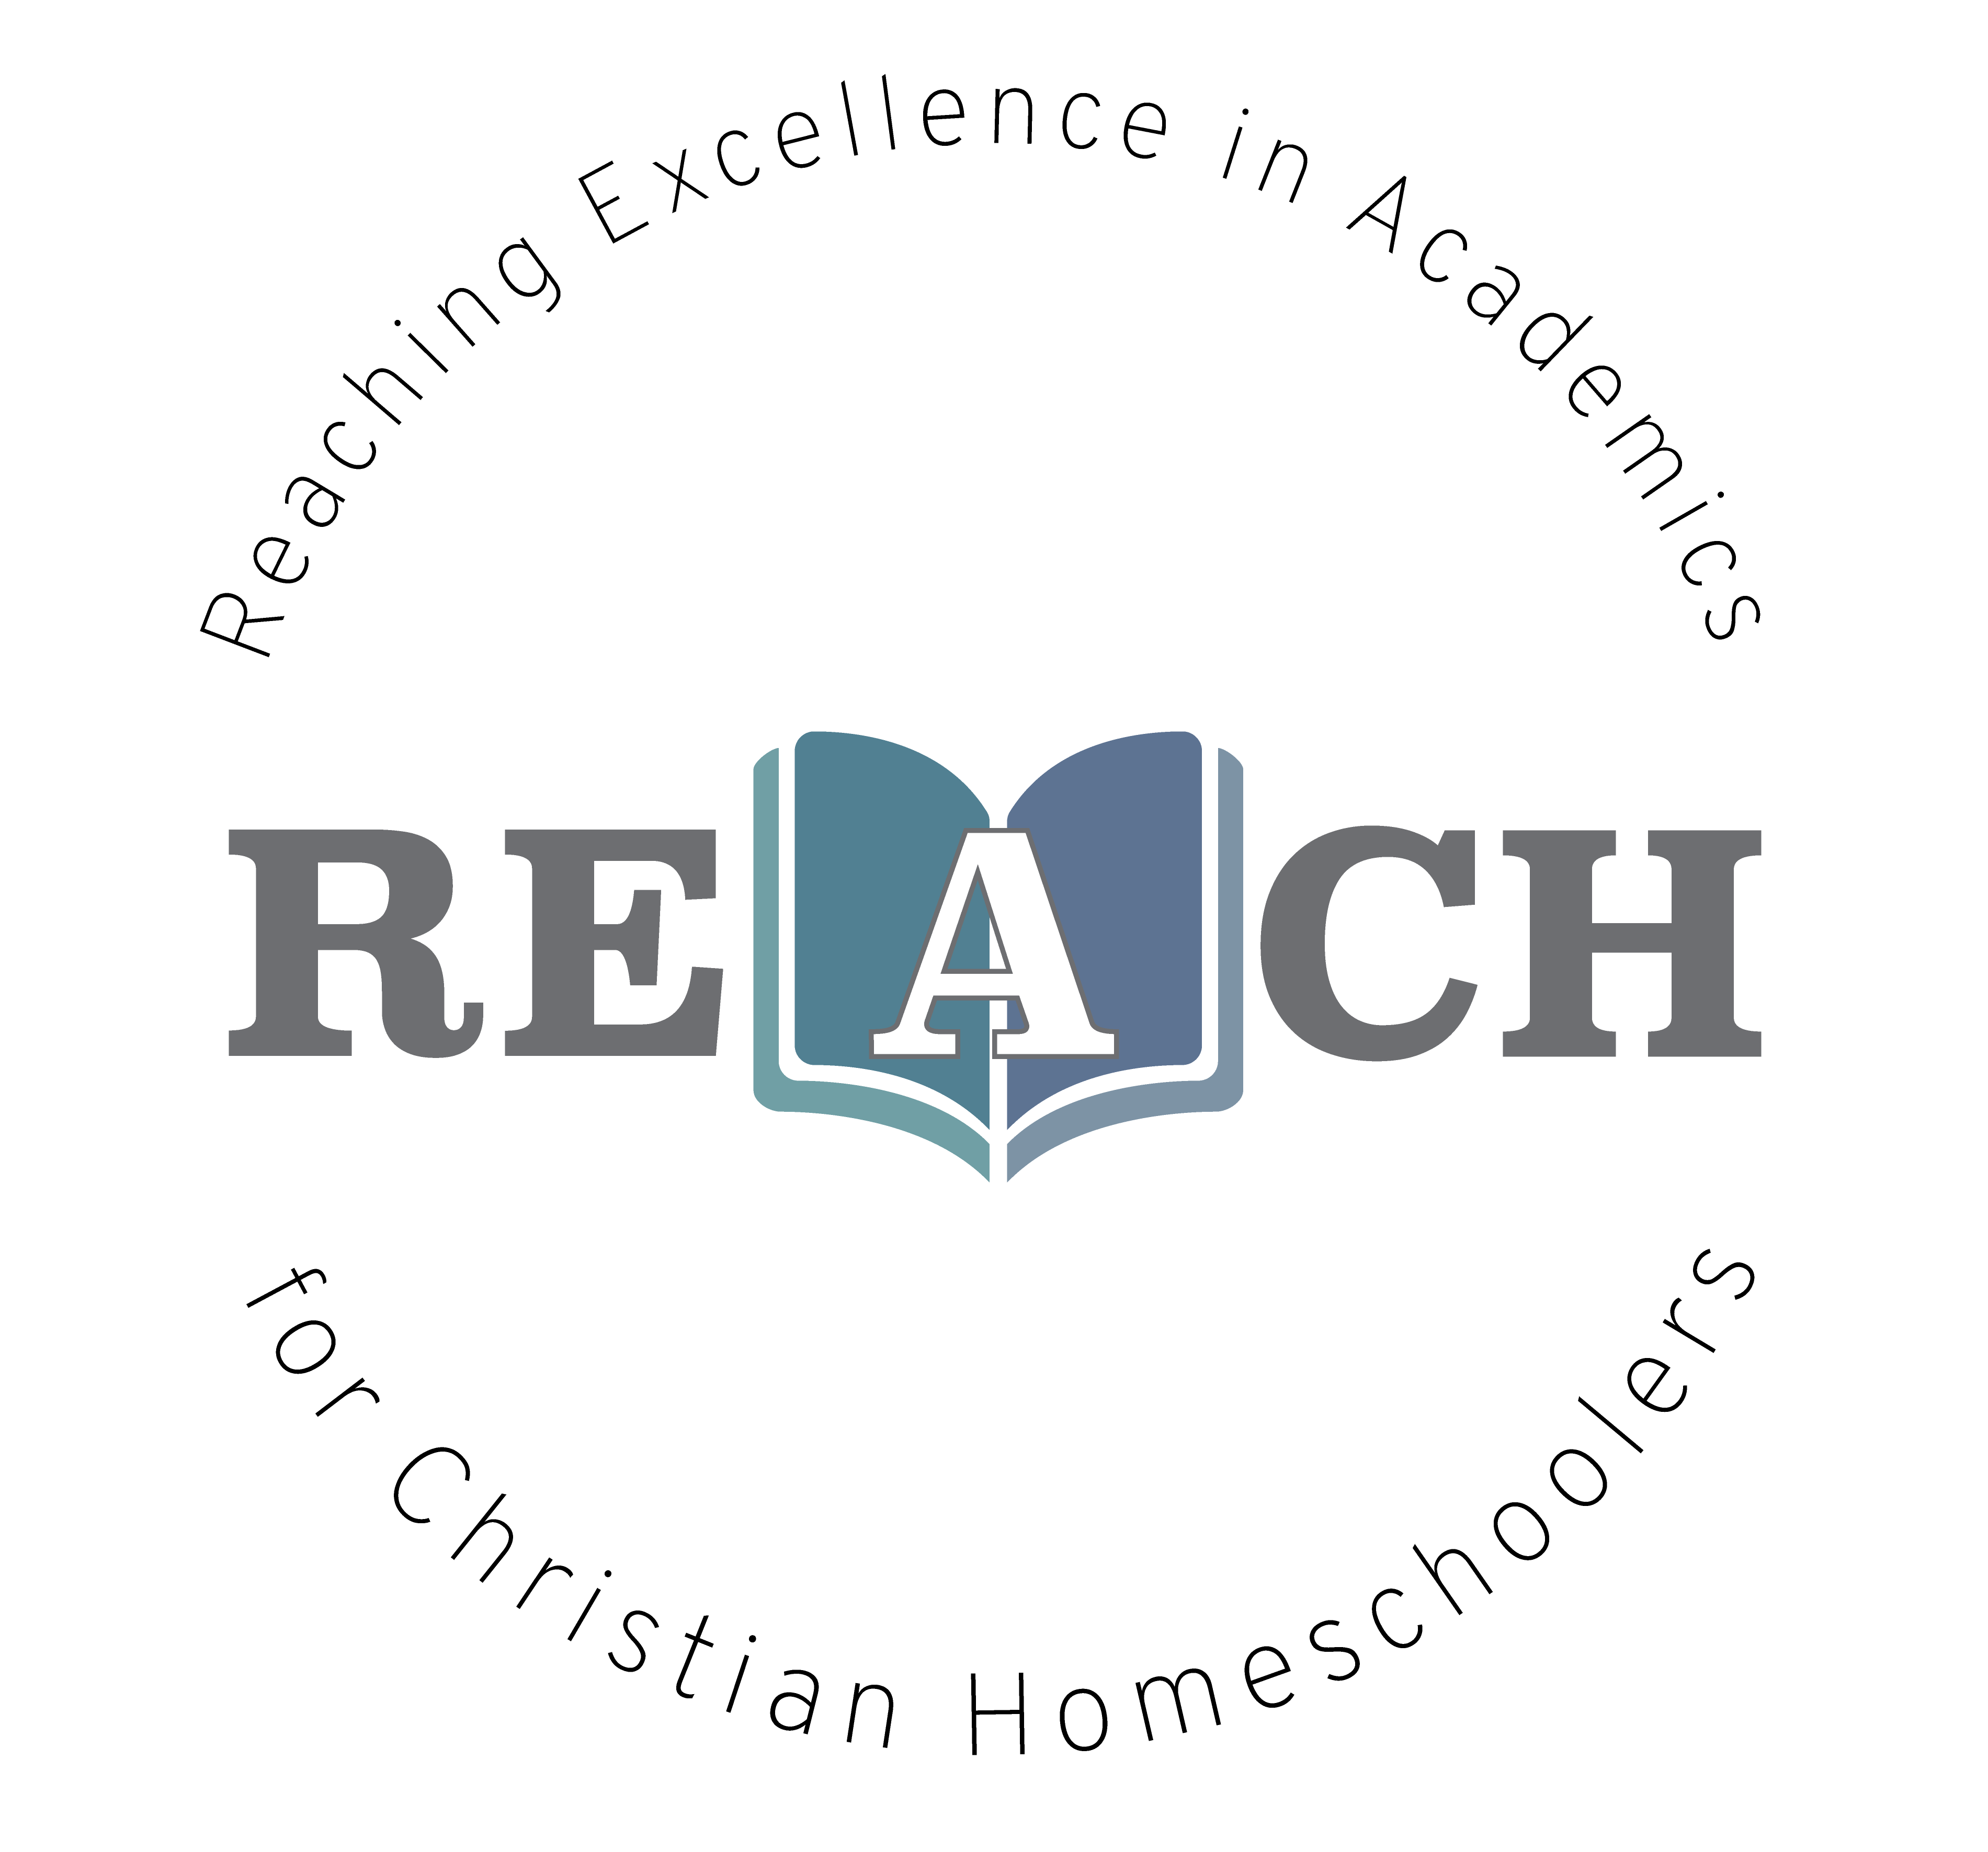

Have you ever wanted to know why we see the moon out during the daytime, how deep the ocean is, or why we have seasons? Have you ever wanted to learn more about our planet or the planets in our solar system? We will discover some amazing facts as we blast off into space, swim into the depths of our oceans, and roam around our planet earth. We will learn about volcanoes, earthquakes, and so much more as we journey around this sphere. Let’s discover a whole new world of God’s creation together!

Christian Kids Explore Earth and Space
Mrs. Christine Filipek~
I live on a small farm in southeast Michigan with my wonderful family. My husband, who is a music teacher, and I have been homeschooling our four children for over 20 years. Autumn is our oldest, she graduated from Pensacola Christian College studying education and art. Our son, Wesley is a senior and our Daughter is a sophomore at Pensacola Christian College. Molly is a senior at home studying veterinarian medicine. We LOVE animals, we have 2 horses, a goat, tons of chickens, 3 turkeys (named Thanksgiving, Christmas, and Easter ), a bunny, several cats, a parrot, lovebird and 2 dogs, Pete and Tucker. We have had the opportunity to raise many domestic and wild animals. I love gardening, reading, sewing, watching movies (going to the drive-in) and hanging out with my family! Besides teaching my own children over the years, I also helped several families in my home by sharing my love for science. I love the hands on aspect of science. I love the hands-on aspect, it helped us understand so much more of what we were learning and it was so much FUN! I own and operate REACH Tutorial, teaching a variety of science classes and Latin to all ages. Both my husband and I are very active in our local and state homeschool groups. We have served on the boards of two local homeschool groups for over 15 years and look forward to helping other homeschool families.

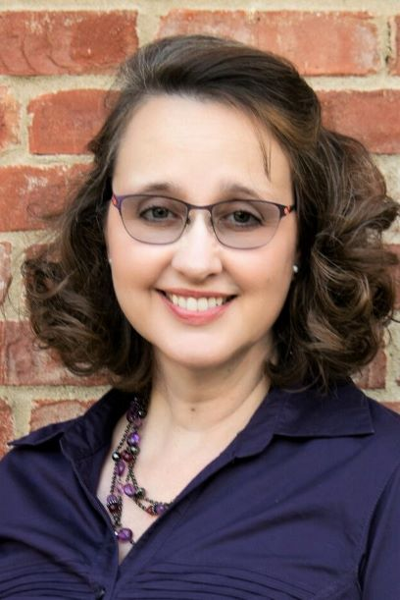
REACH Tutorial

Class Information

Class Name: Self Paced Christian Kids Explore Earth and Space

Teacher Information

Teacher: Christine Filipek
Email: mrscfilipek@gmail.com

Required Course Materials

Christian Kids Explore Earth and Space by Stephanie Redmond, published through Bright Ideas Press. Various household materials will be used and can be found on pages 2, 26, 78-79, 157, and 207.

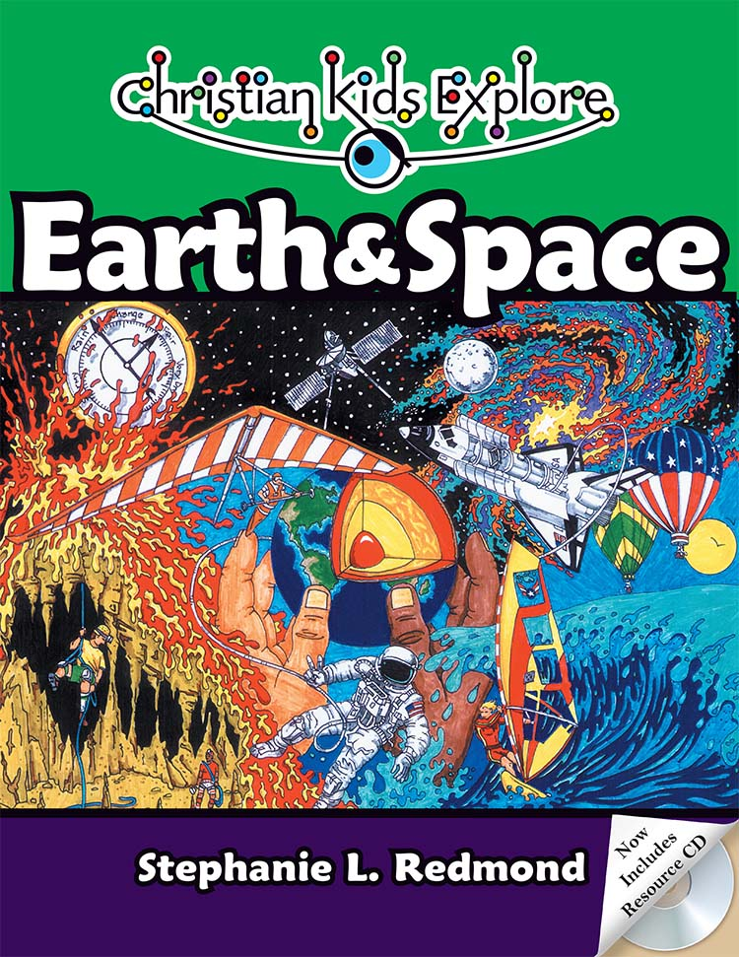

Student Success
Whatever you do, work heartily, as for the Lord and not for men (Col 3:23 ESV)
So, whether you eat or drink, or whatever you do, do all to the glory of God. (1Cor 10:31 ESV)

Let the thief no longer steal, but rather let him labor, doing honest work with his own hands, so that he may have something to share with anyone in need. (Eph 4:28 ESV)
The plans of the diligent lead surely to abundance, but everyone who is hasty comes only to poverty. (Prov 21:5 ESV)
Pray for us, for we are sure that we have a clear conscience, desiring to act honorably in all things. (Heb 13:18 ESV)
Whoever pursues righteousness and kindness will find life, righteousness, and honor. (Prov 21:21 ESV)
Whoever walks in integrity walks securely, but he who makes his ways crooked will be found out. (Prov 10:9 ESV)

Grading Policy
Course Grading Scale (in percent):
A 96-100
A- 90-95
B+ 87-89
B 83-86
B- 80-82
C+ 77-79
C 73-76
C- 70-72
D+ 67-69
D 63-66
D- 60-62
F 0-59

Categories
Weekly assignments 50% of final grade
Assessments/quizzes 50% of final grade
100% total

Philippians 4:8
Finally, brethren, whatever is true, whatever is honorable, whatever is right, whatever is pure, whatever is lovely, whatever is of good repute, if there is any excellence and if anything worthy of praise, dwell on these things.

CKE Self-Paced Earth and Space Schedule with Mrs. Filipek
 |  | Chapters | Lesson | Assessment
1 |  | 1-2 | Earth’s creation | Chapter 1-2 reading
2 |  | 3-4 | Plate tectonics and caves | Chapter 3-4 reading
3 |  | 5-6 | Volcanoes and earthquakes | Chapter 5-6 reading
4 |  | 7 | Rocks | Review over chapters 1-7
5 |  | 8-9 | Water, water, water! | Chapter 8-9 reading
6 |  | 10-11 | Glaciers and Icebergs | Review over chapters 8-11
7 |  | 12 | Layers of the atmosphere | Chapter 12 reading
8 |  | 13-14 | Atmospheric pressure and humidity | Chapter 13-14 reading
9 |  | 15 | Air composition | Review over chapter 12 -15
10 |  | 16-17 | Weather, seasons and cloud formation | Chapter 16-17 reading
11 |  | 18-19 | Precipitation, thunderstorms and tornadoes | Chapter 18-19 reading
12 |  | 20 | Hurricanes | Review over chapters 16-20
13 |  | 21-22 | The universe and our sun | Chapter 21-22 reading
14 |  | 23 | The Moon | Chapter 23 reading
15 |  | 24 | The Planets | Review over chapters 21-24

Copyright:
Copyright © 2017 by Michelle Glandon. All rights reserved. No part of this publication may be reproduced or shared by any means without prior written permission of the publisher. Send permission requests to mrs.glandon@icloud.com.

