Have you ever wondered where everything on this earth came from? Let’s travel back in time and explore the earth when it was new. We will discover when each animal was created, even dinosaurs! In this class we will get a solid foundation of Creation as we discuss both Creation and Evolution. We will learn more about the age of our earth, the great flood, fossils and so many more interesting topics. This class will be an excellent foundation for preparing our children with a Biblical worldview.

Christian Kids Explore Creation Science
Mrs. Christine Filipek~
I live on a small farm in southeast Michigan with my wonderful family. My husband, who is a music teacher, and I have been homeschooling our four children for over 20 years. Autumn is our oldest, graduated from Pensacola Christian College studying education and art. Our son, Wesley is a senior attending Pensacola Christian College and Ellie is a sophomore studying nursing. Molly is a senior at home. We LOVE animals, we have 2 horses, a goat, tons of chickens, 3 turkeys (named Thanksgiving, Christmas, and Easter ;) ), a bunny, several cats, a parrot, lovebird and 2 dogs, Pete and Tucker. We have had the opportunity to raise many domestic and wild animals. I love gardening, reading, sewing, watching movies (going to the drive-in) and hanging out with my family! Besides teaching my own children over the years, I also helped several families in my home by sharing my love for science. I love the hands-on aspect of science. I love the hands on aspect, it helped us understand so much more of what we were learning and it was so much FUN! I own and operate REACH Tutorial, teaching a variety of science classes and Latin to all ages. Both my husband and I are very active in our local and state homeschool groups. We have served on the boards of two local homeschool groups for over 15 years and look forward to helping other homeschool families.

REACH TuTORIAL

Class Information

Class Name: Self Paced Christian Kids Explore Creation Science

Teacher Information

Teacher: Christine Filipek
Email: mrscfilipek@gmail.com

Required Course Materials

Christian Kids Explore Creation Science by Robert Ridlon Jr. and Elizabeth Ridlon , published through Bright Ideas Press. Various household materials will be used and can be found on pages 3, 68, 129, 200, and 248.

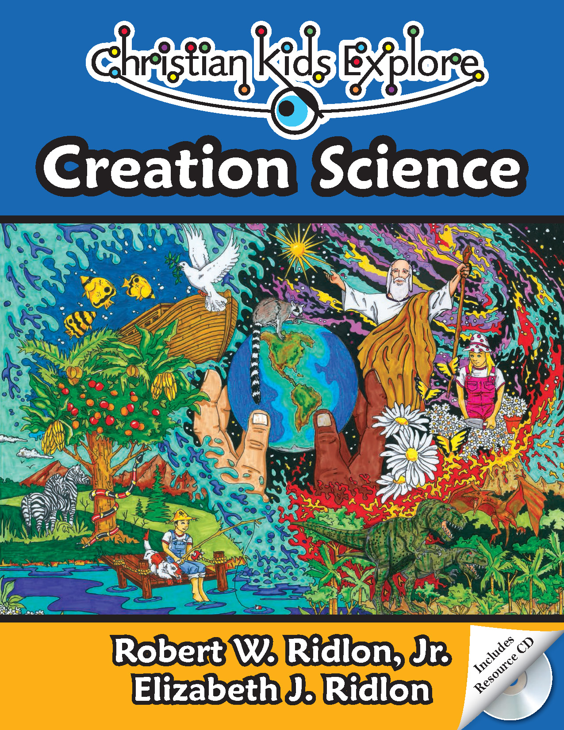

Student Success
Whatever you do, work heartily, as for the Lord and not for men (Col 3:23 ESV)
So, whether you eat or drink, or whatever you do, do all to the glory of God. (1Cor 10:31 ESV)

Let the thief no longer steal, but rather let him labor, doing honest work with his own hands, so that he may have something to share with anyone in need. (Eph 4:28 ESV)
The plans of the diligent lead surely to abundance, but everyone who is hasty comes only to poverty. (Prov 21:5 ESV)
Pray for us, for we are sure that we have a clear conscience, desiring to act honorably in all things. (Heb 13:18 ESV)
Whoever pursues righteousness and kindness will find life, righteousness, and honor. (Prov 21:21 ESV)
Whoever walks in integrity walks securely, but he who makes his ways crooked will be found out. (Prov 10:9 ESV)
Make sure you do your own work and do it in a timely manner.

Grading Policy
Course Grading Scale (in percent):
A 96-100
A- 90-95
B+ 87-89
B 83-86
B- 80-82
C+ 77-79
C 73-76
C- 70-72
D+ 67-69
D 63-66
D- 60-62
F 0-59

Categories
Weekly assignments 50% of final grade
Assessments/quizzes 50% of final grade
100% total

Philippians 4:8
Finally, brethren, whatever is true, whatever is honorable, whatever is right, whatever is pure, whatever is lovely, whatever is of good repute, if there is any excellence and if anything worthy of praise, dwell on these things.

Self paced Creation Science Schedule with Mrs. Filipek
 |  | Chapters | Lesson | Assessment
1 |  | 1 | Creation and Evolution | Chapter 1 reading
2 |  | 2-3 | The beginning of Life | Chapter 2-3 reading
3 |  | 4-5 | Diversity of Life species and variations | Chapter 4-5 reading
4 |  | 6 | Dinosaurs | Review over chapters 1-6
5 |  | 7-8 | First two days of creation | Chapter 7-8 reading
6 |  | 9-10 | Day 3 and 4 of creation | Chapter 9-10 reading
7 |  | 11-12 | Day 5 and 6 of creation | Review of chapters 7-12
8 |  | 13-14 | Noah’s flood | Chapter 13-14 reading
9 |  | 15-16 | Flood and fossils | Review over chapters 13-16
10 |  | 17-18 | Age of the earth and radiometric measurement | Chapter 17-18 reading
11 |  | 19-20 | What is evolution? | Chapter 19-20 reading
12 |  | 21-23 | Evolution tried to explain life | Review over chapter 19-23
13 |  | 24-25 | Intelligent design | Chapter 24-25 reading
14 |  | 26-27 | Life on Mars | Chapter 26-27 reading
15 |  | 28 | What we believe matters | Review over chapters 24-28

Copyright:
Copyright © 2017 by Michelle Glandon. All rights reserved. No part of this publication may be reproduced or shared by any means without prior written permission of the publisher. Send permission requests to mrs.glandon@icloud.com.

