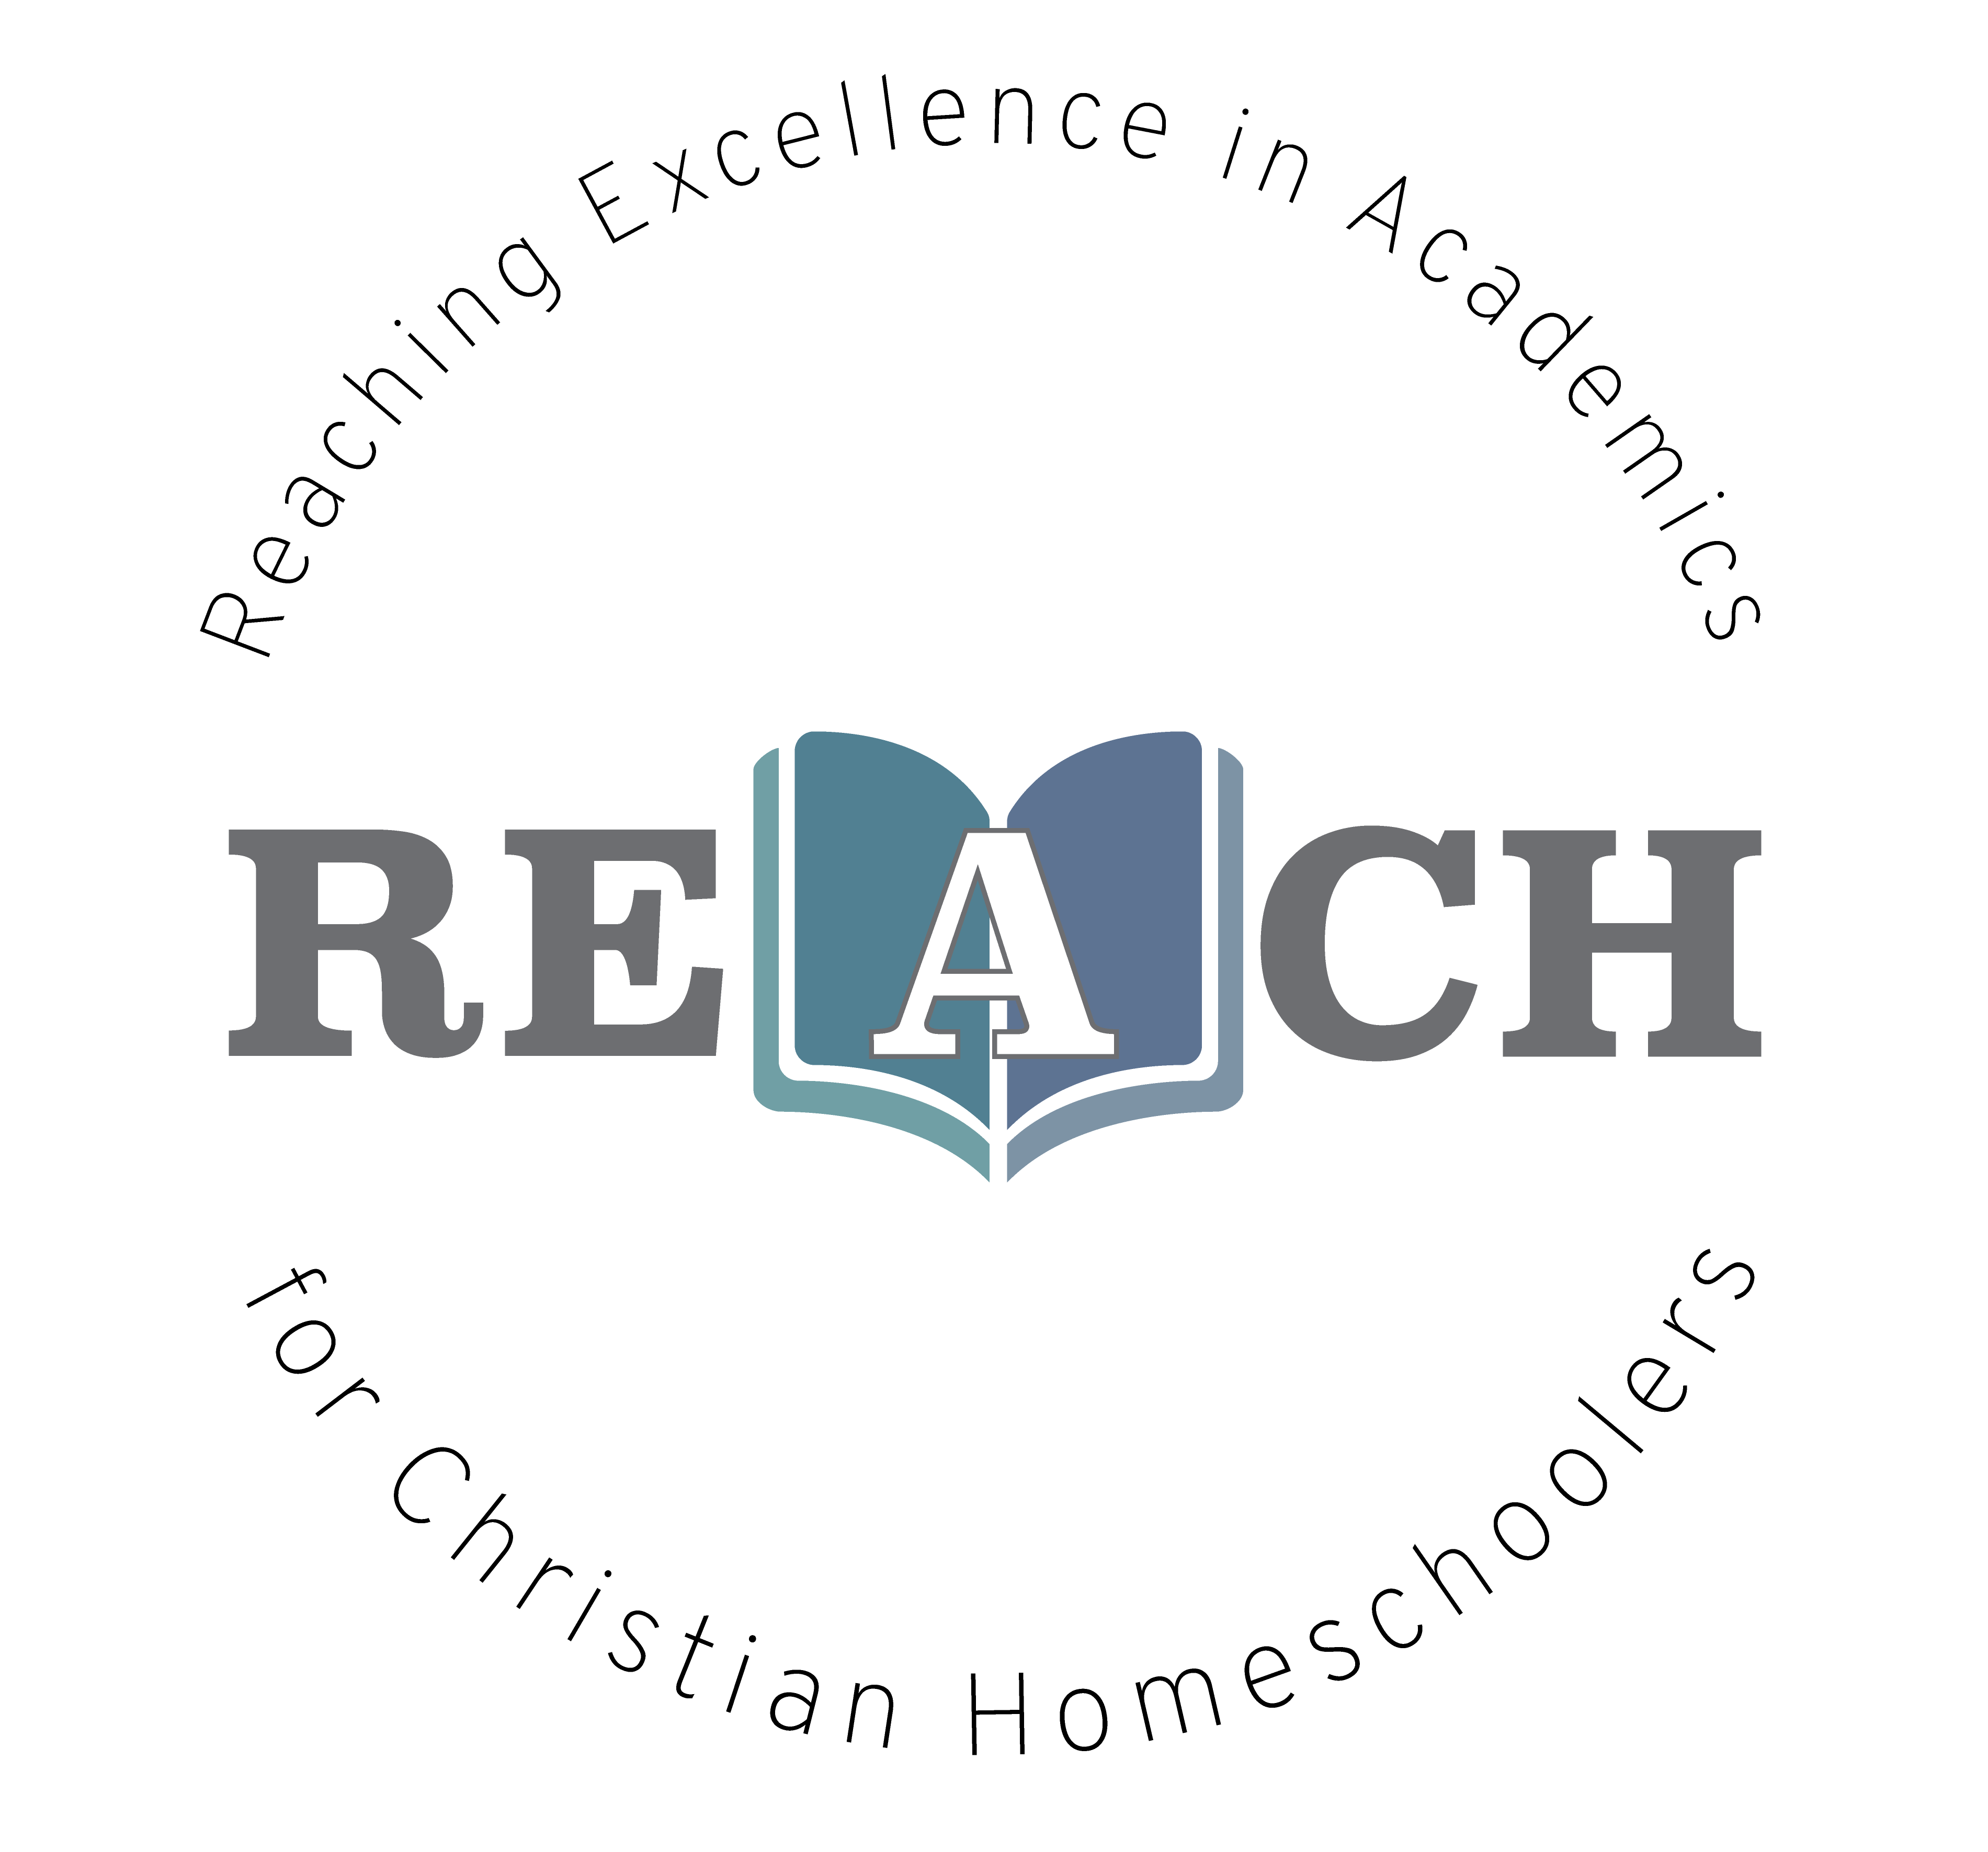
Have you ever wanted to learn more about where our world came from? How plants and animals live? Have you ever been curious about how your body works, down to the smallest cells? Biology gives an excellent overview of life sciences- starting with the classification system. Students will learn about what the characteristics of life are, germinate and grow seeds, and learn about the building block of life-the cell- what its structures and functions are, how it divides, and how the DNA inside the cell works. Students will make their own cell model with labeled structures. We will take an exciting adventure, learning more about the wonderful creations and creatures that God has given us!

Christian Kids Explore Biology
Mrs. Christine Filipek~

I live on a small farm in southeast Michigan with my wonderful family. My husband, who is a music teacher, and I have been homeschooling our four children for over 20 years. Autumn is our oldest, she graduated from Pensacola Christian College with a degree in education and. Our son, Wesley, is a senior studying criminal justice and Ellie is a sophomore studying nursing at Pensacola Christian. Molly is a senior at home studying veterinarian medicine. We LOVE animals, we have 2 horses, a goat, tons of chickens, 3 turkeys (named Thanksgiving, Christmas, and Easter), a bunny, several cats, a parrot, lovebird and 2 dogs, Pete and Tucker. We have had the opportunity to raise many domestic and wild animals. I love gardening, reading, sewing, watching movies (going to the drive-in) and hanging out with my family! Besides teaching my own children over the years, I also helped several families in my home by sharing my love for science. I love the hands-on aspect of science. I love the hands on aspect, it helped us understand so much more of what we were learning and it was so much FUN! I own and operate REACH Tutorial, teaching a variety of science classes and Latin to all ages. Both my husband and I are very active in our local and state homeschool groups. We have served on the boards of two local homeschool groups for over 15 years and look forward to helping other homeschool families.

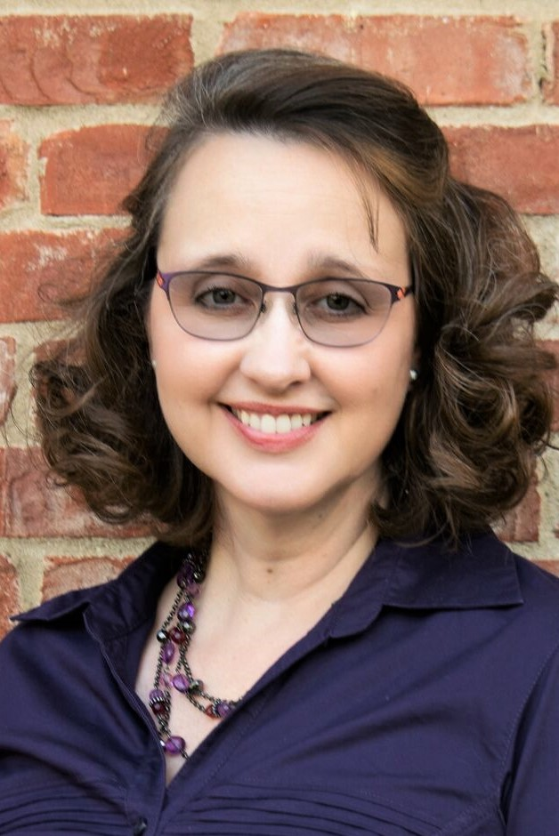
REACH TUTORIAL

Class Information

Class Name: Christian Kids Explore Biology

Teacher Information

Teacher: Christine Filipek
Email: mrscfilipek@gmail.com
Phone, for emergencies only: 517 445-2160

Required Course Materials

Christian Kids Explore Biology by Stephanie L. Redmond ISBN 1-892427-05-2 Published through Bright Ideas Press.
Other various household supplies are listed on pages 2, 26, 52, 68, 88, 116, and 150.

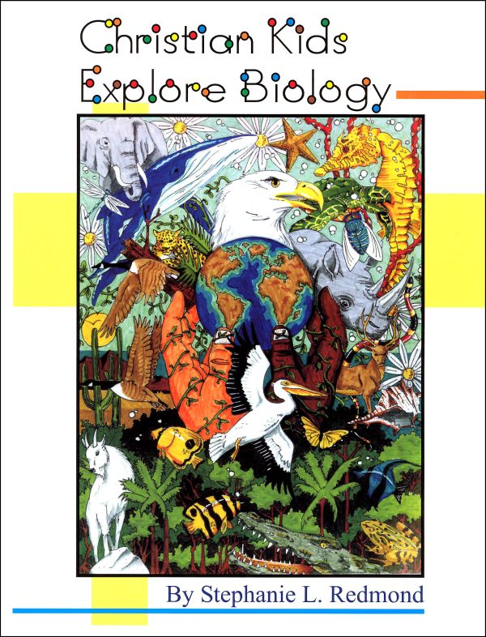

Student Success
Whatever you do, work heartily, as for the Lord and not for men (Col 3:23 ESV)
So, whether you eat or drink, or whatever you do, do all to the glory of God. (1Cor 10:31 ESV)

Let the thief no longer steal, but rather let him labor, doing honest work with his own hands, so that he may have something to share with anyone in need. (Eph 4:28 ESV)
The plans of the diligent lead surely to abundance, but everyone who is hasty comes only to poverty. (Prov 21:5 ESV)
Pray for us, for we are sure that we have a clear conscience, desiring to act honorably in all things. (Heb 13:18 ESV)
Whoever pursues righteousness and kindness will find life, righteousness, and honor. (Prov 21:21 ESV)
Whoever walks in integrity walks securely, but he who makes his ways crooked will be found out. (Prov 10:9 ESV)
Make sure you do your own work and do it in a timely manner. Follow directions. If you are unsure what you are to do, contact the teacher.

Grading Policy
Course Grading Scale (in percent):
A 96-100
A- 90-95
B+ 87-89
B 83-86
B- 80-82
C+ 77-79
C 73-76
C- 70-72
D+ 67-69
D 63-66
D- 60-62
F 0-59

Categories
Weekly assignments 50% of final grade
Assessments/quizzes 50% of final grade
100% total

Philippians 4:8
Finally, brethren, whatever is true, whatever is honorable, whatever is right, whatever is pure, whatever is lovely, whatever is of good repute, if there is any excellence and if anything worthy of praise, dwell on these things.

Biology Schedule with Mrs. Filipek

 |  | Chapters | Lessons | Assessments
1 |  | 1 | Creation | Chapter 1 reading
2 |  | 2-3 | The cell and taxonomy | Chapter 2-3 reading
3 |  | 4-5 | Biospheres and food webs | Review over chapters 1-5
4 |  | 6-8 | Plants and photosynthesis | Chapter 6-8 reading
5 |  | 9-10 | Fruits, vegetables and trees | Review over chapters 6-10
6 |  | 11-13 | Taxonomy and birds | Chapter 11-13 reading
7 |  | 14-16 | Monotremes, marsupials, canids, felines and bears- Oh My! | Review over chapters 11-16
8 |  | 17-18 | Monkeys, apes, and aquatic animals | Chapter 17-18 reading
9 |  | 19-20 | The human body | Review over chapters 17-20
10 |  | 21-22 | Our five senses | Chapter 21-22 reading
11 |  | 23-24 | Snakes and lizards | Chapter 23-24 reading
12 |  | 25-26 | Alligators and crocodiles, turtles, tortoises, and terrapins | Review over chapters 21-26
13 |  | 27-29 | Butterflies and moths, bees and wasps | Chapter 27-29 reading
14 |  | 30-33 | Mollusks, sharks and crustaceans | Chapter 30-33 reading
15 |  | 34-35 | Freshwater life and amphibians | Review over chapters 27-35

Copyright:
Copyright © 2017 by Michelle Glandon. All rights reserved. No part of this publication may be reproduced or shared by any means without prior written permission of the publisher. Send permission requests to mrs.glandon@icloud.com.

